# EXPERIMENT 5A – THREADS AND PROCESS

##### pipe()

Conceptually, a pipe is a connection between two processes, such that the standard output from one process becomes the standard input of the other process. In UNIX Operating System, Pipes are useful for communication between related processes(inter-process communication).

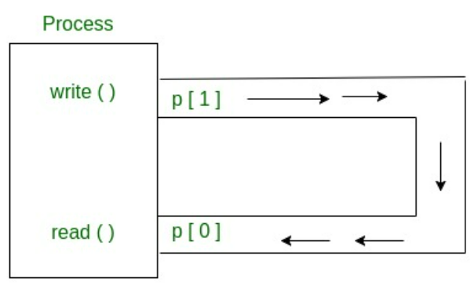

// pipe system call in C

#include <stdio.h>

#include <unistd.h>

#define MSGSIZE 16

**char**\* msg1 = "hello, world #1";

**char**\* msg2 = "hello, world #2";

**char**\* msg3 = "hello, world #3";

**int** main()

{

**char** inbuf[MSGSIZE];

**int** p[2], i;

**if** (pipe(p) < 0)

**exit**(1);

    /* continued */

    /* write pipe */

    write(p[1], msg1, MSGSIZE);

    write(p[1], msg2, MSGSIZE);

    write(p[1], msg3, MSGSIZE);

**for** (i = 0; i < 3; i++) {

        /* read pipe */

        read(p[0], inbuf, MSGSIZE);

**printf**("% s\n", inbuf);

    }

**return** 0;

}

OUTPUT:

hello, world #1

hello, world #2

hello, world #3